**Step 1**

**6.2.1. Authentication Request (**For Fetching the AuthCode from the Authorization server)

[https://sso-int.daimler.com/as/authorization.oauth2?response\_type=code&client\_id=b50ba4a3-4a88-468b-b983-2be670cb5884&redirect\_uri=https://elite-dev1.in623.corpintra.net/login/&scope=openid&acr\_values=daimler:idp:gas:strong profile offline\_access](https://sso-int.daimler.com/as/authorization.oauth2?response_type=code&client_id=b50ba4a3-4a88-468b-b983-2be670cb5884&redirect_uri=https://elite-dev1.in623.corpintra.net/login/&scope=openid&acr_values=daimler:idp:gas:strong profile offline_access )

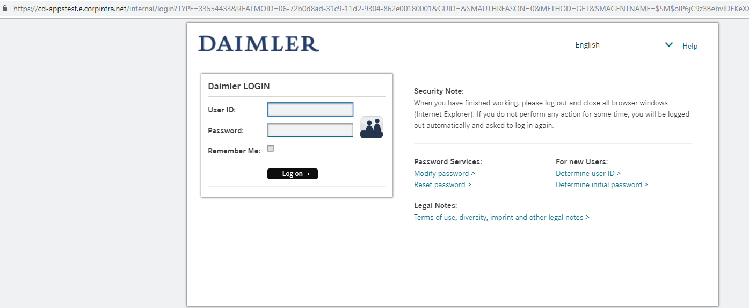

**Step 2**

**6.2.2. Authentication Response**



**Step 3**

**6.2.3. Code Token exchange Page** 20/44(For fetching Access and ID Token)

<https://sso-int.e.corpintra.net/as/token.oauth2>

**Headers**

**Content-Type** application/x-www-form-urlencoded

**Authorization** AuthCode(selected from the redirect URL from Step 1)

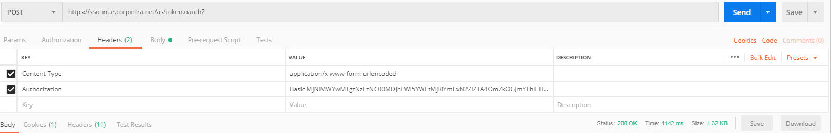

Body

**grant\_type** authorization\_code

**code** *client-id:client-secret* base64 encoded

**redirect\_uri** <https://elite-dev1.in623.corpintra.net>

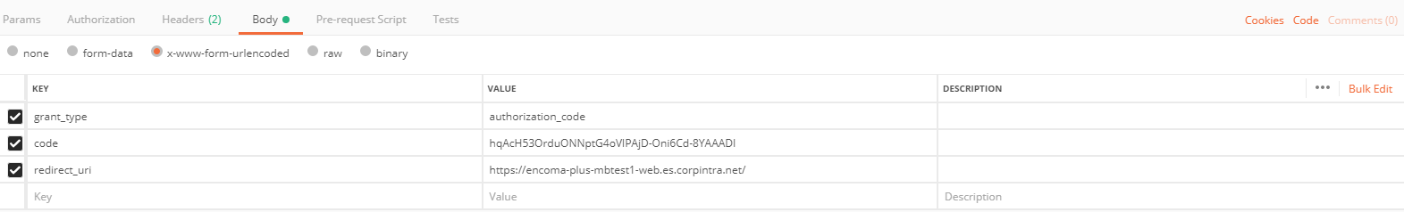

**Output**

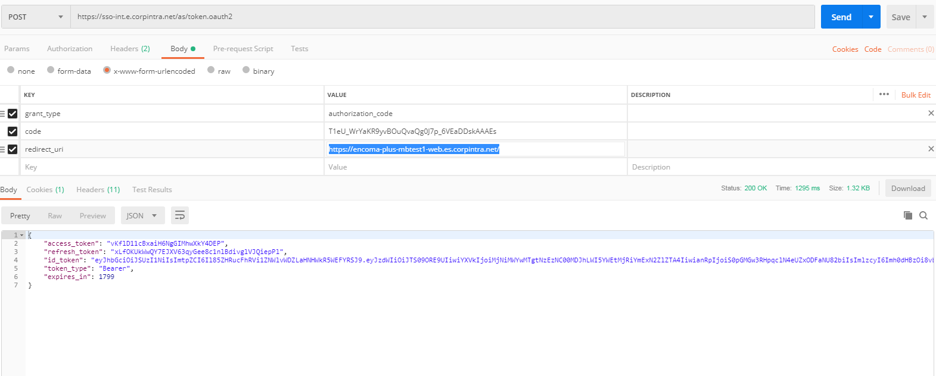

**Step 4**

**6.2.7. Receiving user information**

<https://sso-int.e.corpintra.net/idp/userinfo.openid>

**Headers**

**Authorization Bearer** vKflD11cBxaiH6NgGIMhwXkY4DEP(Access token received from the previous request)

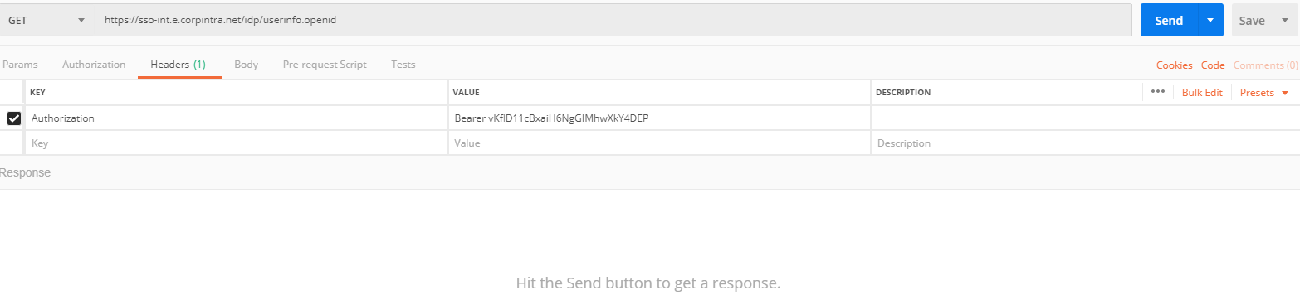

**Output**

